**Analyzing the Pre-Owned Car Market Using Data**

Overview   
The pre-owned car market is characterized by a wide range of vehicles and intricate dynamics. Using data from multiple transactions, we analyze the inner workings of the used car sales industry, revealing the factors that influence pricing, popularity, and consumer preferences.   
  
An overview of the dataset   
The journey commences with a dataset containing comprehensive information on more than 2,000 car sales. This dataset encompasses a wide range of attributes, including make, model, engine power, and fuel type. The oldest automobile recorded in the datasetis in 1988, providing a historical context spanning up to 2022.

Analysis of Pricing

The dataset exhibits a wide range of prices, which serves as a comprehensive measure of value. A histogram, depicted in Figure 1, displays the distribution of cars at various price points, providing information about their frequency. On the other hand, a boxplot, shown in Figure 2, highlights any outliers in the data, indicating the extreme values in the market.

**The Price Spectrum: From Economical Runabouts to Premium Machines**

**Price Highs and Lows for Cars**

Most of the data is concentrated in the lower price range, as indicated by the compact box displaying the interquartile range. The median price, indicated by the line inside the box, represents the dataset's middle value. The concentration of most car prices within a smaller range, with several outliers, suggests that a few cars are significantly more expensive than the others.

**Which Fuel Types Are Most Common?**

With the increasing awareness of the environment, there is also a growing interest in different types of fuel. Figure 3 displays a count plot of cars categorized by their fuel type, providing insight into the market's composition and potentially reflecting consumer sentiment.

**Do More Kilometres Reduce the Price?**

The distance traveled is of great importance. The relationship between price and kilometers driven is depicted in a scatter plot (Figure 4), revealing depreciation or the amount of value cars retain as they age on the road.   
  
**Does Your Location Affect the Cost of a Car?**

Geographic Variation

Delving further, we analyze the impact of location on pricing. The bar plot illustrating the average selling prices according to different locations. This plot reveals regional economic stories, potentially indicating differences in demand or the cost of living.

Figure 5 displays the average selling price categorized by location.

**Do Automobiles Get Any Cheaper?**

A scatter plot depicting the fluctuation of car prices over time, accompanied by a trend line representing the average price (Figure 6), effectively illustrates the progression of the market, showcasing the impact of technological advancements, inflation, and shifting consumer preferences.

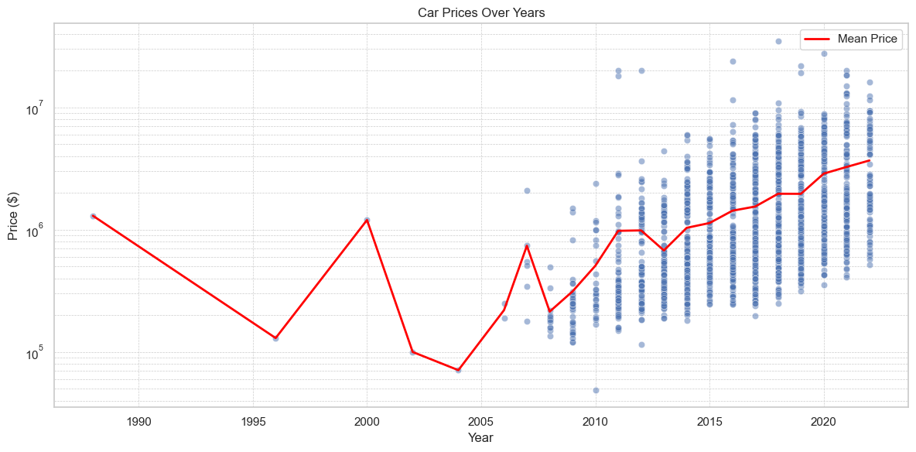  
Figure 6: Car Prices Over Time

**Conclusion**

The dataset leads us through narratives constructed by numbers, ranging from empirical evidence to anecdotal accounts. The text discusses a market that is affected by various factors, including economic, environmental, and temporal influences. These insights provide stakeholders in the automotive industry with the necessary information to make informed decisions, set strategic prices, and gain a deeper understanding of consumer preferences.